Add Directional Relative Permeability to GPRS

Yaqing Fan

Last modified on: April 19, 2007

1. Introduction
Under reservoir conditions, the relative permeabilities are usually not following the same relative permeability curves in different directions. Such dependency makes the mobilities of phases functions of not only saturation, but also directions. GPRS has been modified to take into account of directional relative permeability for both black oil model and compositional model in the context of two-point flux approximation. Multi-point flux approximation does not have the option of directional relative permeability, neither does thermal simulations.

2. GPRS Implementation

To use directional relative permeability option, one have to add an additional section right after Rock_Fluid section in the input file. The layout of the input file is shown below:
MULTI_ROCKFLUID #####################################

INCLUDE multirock.dat
DIRKR
INCLUDE krnx.dat
INCLUDE krny.dat
INCLUDE krnz.dat

END
MULTI_ROCKFLUID #####################################

INCLUDE multirock.dat
DIRKR
INCLUDE krnx.dat
INCLUDE krny.dat
INCLUDE krnz.dat

END

In the box, MULTI_ROCKFLUID is the keyword indicating that more than one set of relative permeability tables are available. DIRKR is the keyword telling us that directional relative permeability option is activated. Three additional files are included, as shown in the box above. It’s advisable to include separate files. The first file multirock.dat, beginning with an integer of how many additional relative permeability tables will be added, includes all the additional relative permeability tables. A typical file format of multirock.dat is shown in the following box.
2 # No. of extra rel. perm. sets
OW #-----------set 1---------------
NUM_OF_TABLE_ENTRIES 2
0.00000000 0.00000000 1.00000000 0.00000000
0.85000000 0.43000000 0.00000000 0.00000000
END
OW #-----------set 2---------------
NUM_OF_TABLE_ENTRIES 2
0.00000000 0.00000000 1.00000000 0.00000000
0.85000000 0.60000000 0.00000000 0.00000000
END

Note that if one wants to use this option in three-phase cases, “an extra rel. perm. set” is composed of two tables, gas-oil relative permeability table and oil-water relative permeability table. For example, in the box above, one needs to add each gas-oil (GO) relative permeability table after each oil-water (OW) relative permeability table. It won’t work in other orders.

Another three files are needed after the keyword DIRKR, each specifying the index of the relative permeability table that each cell will be applied to. For example, in the y direction, a typical input file for a reservoir with 5 grid blocks is shown below. Note that 0 means for that cell, default relative permeability is applied, and 1 means the first additional relative permeability table applies.

KRNY #rel. perm. Index for y direction
1
0
1
2
1
If all the numbers of these three files are the same, i.e., for each block the same set of relative permeability table applies, one can use a shortcut way to do it: in addition to omitting DIRKR, only one column of data is needed, as shown below.

KRN #rel. perm. Index for all directions
0
0
1
2
3

3. Example Cases

3.1 Black-oil case

In this case, a heterogeneous reservoir is tested in black-oil simulation with two horizontal wells. For its 11x11x5 blocks, each has three different relative permeability tables for x, y, and z directions. Additional 20 relative permeability tables are used in near well regions. The parameters for this case are listed in the following table.

Parameter | Value
Nx | 11
Ny | 11
Nz | 5
Dx (ft) | 50
Dy (ft) | 50
Dz (ft) | 25
Porosity | 0.25
Phases | Oil, Water
Well control | 1 Horizontal Injector: BHP (7000 psia);  1 Horizontal Producer: BHP (3000 psia)
The results are shown in the following figures, comparing Eclipse with directional relative permeability options. We can see a close match.

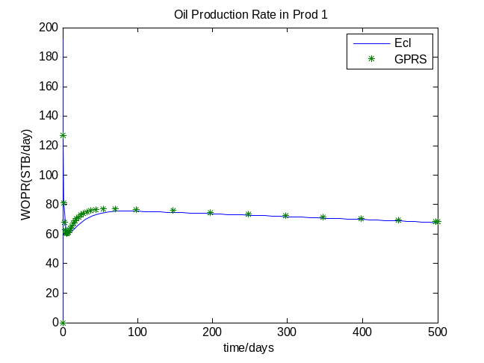
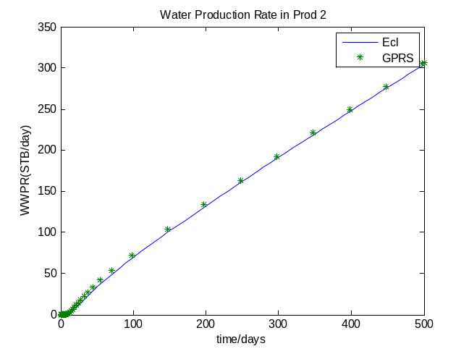
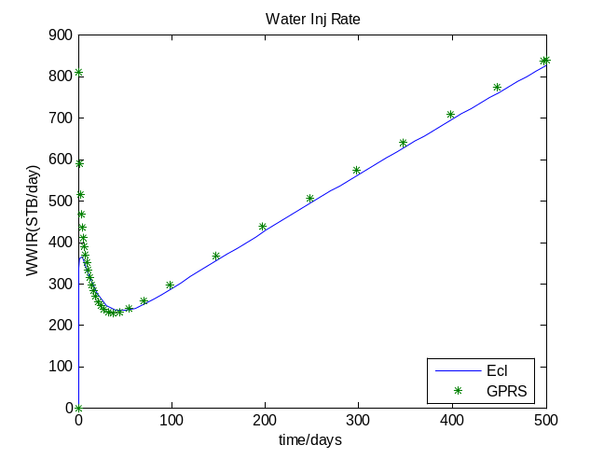

3.2 Compositional case

In the second case, a two-phase compositional case is tested in a homogeneous reservoir. For the 5x5x5 blocks, there are totally 375 additional relative permeability sets are provided, each cell with 3 for x, y, and z directions. The parameters for this case are summarized in the table below.

Parameter | Value
Nx | 5
Ny | 5
Nz | 5
Dx (ft) | 1000
Dy (ft) | 1000
Dz (ft) | 10
Kx (md) | 100
Ky (md) | 100
Kz (md) | 10
Porosity | 0.10
Components | CO2 N2 C1 C2 C3 C4-6 C7+1 C7+2 C7+3
Injector | Block (1,1,1)
Producer | Block (5,5,5)
Well control | Injector: BHP (3000 psia);  Producer: BHP (1000 psia)

The results are plotted against Eclipse results. We can see a close match.
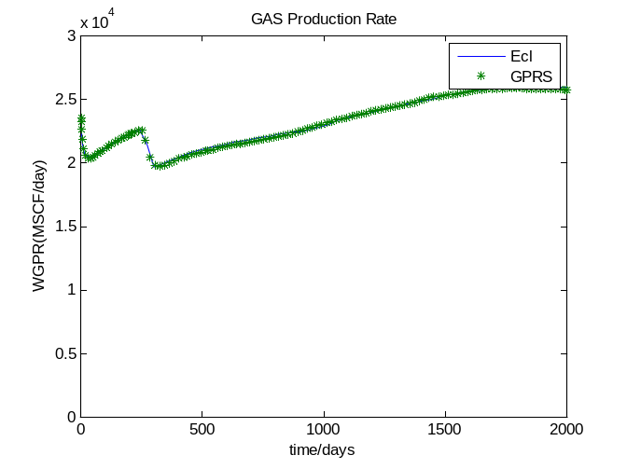

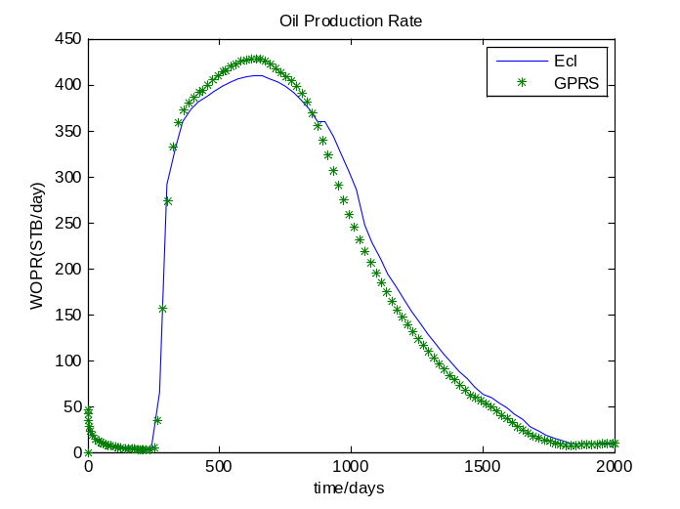
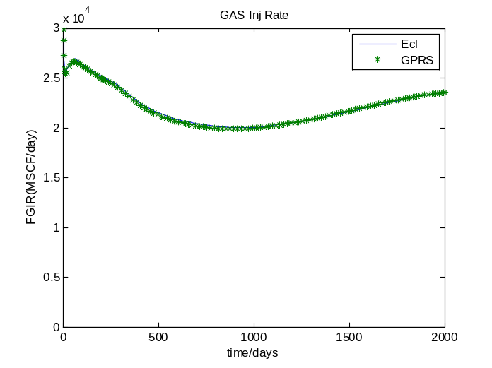

4. Conclusions

Directional relative permeability capability is added to GPRS. Close results are obtained comparing to the same capability of Eclipse. Currently, this option is only available to iso-thermal simulations using two-point flux approximation. Also, due to the fact that GPRS and Eclipse couldn’t always match in three-phase cases, one has to be sure your case yields matched results from Eclipse and GPRS before applying this option.

